Our work
Farmer’s Connet
Page Banner on Farmers cultivating, scroll with diff pics. With central message "Empowering Earth's Stewards"
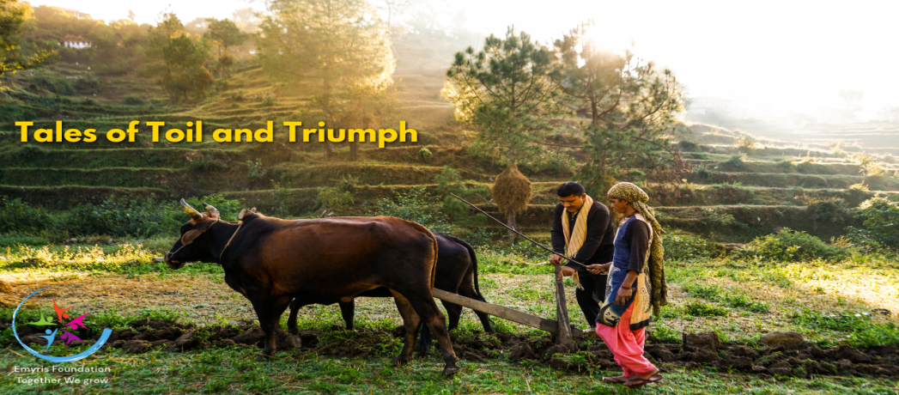
Why Farmer’s Connect?
In India – we are proud of our agricultural heritage however the harsh realities of farmer distress, underscoring the urgent needs for comprehensive, effective agricultural policies those truly uplift farmers, aligning with the broader goals of nation-building. Protecting farmers' interests is not just about economic support but ensuring their voices are heard in shaping agricultural policy, which directly influences national food security, economic stability, and environmental health. Farmers are the backbone of any nation's agricultural sector, which is often the foundation of its economy, particularly in developing countries like us.

What We Do
Agriculture contributes significantly to GDP, employment, and rural development. Plays a crucial role in environmental health, including soil conservation, water management, and biodiversity. Where direct benefits like subsidies, loans, and insurance schemes (like PM-KISAN, Fasal Bima Yojana), infrastructure development for irrigation and market linkage, and promoting organic and sustainable farming practices is yielding positive outcomes, challenges remain, particularly in equitable distribution of benefits, addressing climate change impacts, and ensuring farmers have a voice in policy-making.

Workshops & Training | Online Platforms and Apps | Peer Learning and Farmer-to-Farmer Networks | Demonstration Farms | Promoting Sustainability
Organizes training with support of agricultural colleges’, technical experts, covers from soil testing, market economics to integrated farming and crop diversification. | Utilizing technology for real-time advice, market information, and educational content directly accessible to farmers, even in remote areas. | Encouraging experienced farmers to mentor less experienced ones, fostering a culture of continuous learning. | Practical learning through model farms where new techniques are showcased. | Encouraging practices that promote soil health, reduce chemical use, and enhance biodiversity.

IMPACT 24-25
Farmers cultivating, farmers meeting, farmer workshop PHOTOGRAPHS AND MESSAGE WILL APPEAR HERE.
REACH & PRESENCE
ACTIVITIES DONE IN DIFFERENT AREAS WILL APPEAR WITH MESSAGE. Messagewill appear inside circle.
3 Farmers association

3 Farmers association 1 states 1 projects 4 future projects
TOGETHER WE ARE GROWING
RAVI
A farmer from Odisha, thanked for our support and help in improving his knowledge on Organic Cultivation
4 farmers photographs with message will appear here.. Below botton view all for more such details.
THEIR SUCCESS, OUR HAPPINESS
Youtube videos will appear here with scroll option.<>

